Name: Session:
Principles of Engineering
Lunar Lander in Excel Project

In this exercise, you will use Excel to create a Lunar Lander simulation in Excel.

- Create a new workbook in Excel.

- Place a your initial values in cells as such

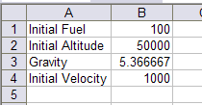

- Add column headings for Time, Burn, Fuel, Velocity, and Altitude as well as time values from 0 to 170 as shown.

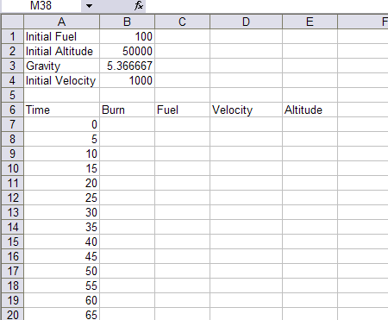

- Add the following formulas in the following cells:

C7 =IF(B7,B1-B7,"")
D7 =IF(B7,B4-30*B7+5*$B$3,"")
E7 =IF(B7,B2-D7*5-0.5*$B$3*25,"")
F7 =IF(E7<0,IF(D7<50,"You landed safely","You crashed"),"")

C8 =IF(B8,C7-B8,"")
D8 =IF(B8,D7-30*B8+5*$B$3,"")
E8 =IF(B8,E7-D8*5-0.5*$B$3*25,"")

- Now copy the formulas in C8 to cells C9 to C41.

- Copy the formula in D8 to cells D9 to D41.

- Copy the formula in E8 to cells E9 to D41

- Copy the formula in F7 to cells F8 to F41.

- Now add a chart (choose a X-Y scatter plot) to plot the cells A7 to A41 and E7 to E41. Your final spreadsheet should look like this. As you enter burn values in the burn column, the spreadsheet will calculate your new velocity and altitude and plot the altitude vs. time and the graph so you can attempt to come in for a smooth landing….

- Good luck…

